

SECP 1513 - Section 07

Technology and Information System

**DESIGN THINKING PROJECT REPORT:**

**UTM AI-TTENDANCE**

Lecturer: Dr. Suriati binti Sadimon

**Group 6**

|  |  |
| --- | --- |
| NAME | MATRIC NO. |
| DHIVYESH KUMAR A/L SIVAKUMAR | A25CS0212 |
| MUHAMMAD FAIZ IRFAN BIN JAMALLUDIN | A25CS0268 |
| MUHAMMAD ZAHIN FARIS BIN LOKMAN | A25CS0284 |
| MUHAMMAD ALIFF NORMAN BIN ADNAN | A25CS0262 |
| AHMAD MUAZ BIN MUHAMAD THALHAH | A25CS0177 |

**CONTENTS**

PAGE

**1.0 INTRODUCTION** **3**

**2.0 DETAILED DESCRIPTION**  **4**

2.1 Design Thinking Process 4

2.1.1 Empathy 4

2.1.2 Define 4

2.1.3 Ideate 5

2.1.4 Prototype 6

2.1.5 Test 6

2.2 Problem, Solution, Teamworking 7

2.2.1 Problem 7

2.2.2 Solution 7

2.2.3 Teamworking 7

**3.0 DESIGN THINKING ASSESSMENT** **8**

3.1 End of Project Demonstration 8

3.2 Transitions Between Design Thinking Phases 8

**4.0 DESIGN THINKING EVIDENCE** **9**

4.1 Sample Work 9

4.2 Record for Each Phase 17

4.2.1 Empathy 17

4.2.2 Define 19

4.2.3 Ideate 20

4.2.4 Prototype 21

4.2.5 Test 27

**5.0 REFLECTIONS 28**

**6.0 TASK DELEGATION 30**

**7.0 REFERENCES 31**

**1.0 INTRODUCTION**

Design thinking is a professional approach where it involves inventiveness and creativity to come up with a unique solution step by step to fix daily problems. It is a very useful concept when utilized to get a grip on the largest problems that are too complex to achieve human comprehension. This process can be divided into five core stages: empathy, define, ideate, prototype and test.

After the empathy phase, we identified that most people, especially students, have issues with the current QR attendance system. The existing application which is UTMSmart is recognized to have issues and we come up with solutions to fulfil user needs. In our study, we are primarily focused on a student attendance system that uses a self-designed biometric face scanner. The scanner detects student faces and uses AI and biometrics face systems to facilitate facial data recognition and sends the data to UTMDigital servers. AI is a technology with a set of algorithms that imitates complex neuron activities in humans by analyzing the environment carefully and providing solutions to give some aid in specific tasks. Biometrics face systems involve variability in data that contain biometric samples such as fingerprint pattern, iris pattern and facial pattern.

**2.0 DETAILED DESCRIPTION**

**2.1 Design Thinking Process**

**2.1.1 Empathy**

According to Hasso Plattner Institute of Design at Stanford (2025), there are three steps that should be carried out for the empathy phase. These include observe, engage and immerse.

**Observation:**

Our team has done observations on how lecturers use MyUTM portal to generate QR codes for an attendance session, documenting how long it takes to generate and display the code. Simultaneously, we monitored how students utilise the UTMSmart app, noting the time taken to scan codes, factors that affected successful scanning and reactions of students when the system fails.

**Engage:**

We have asked questions to several students on their experience using the current attendance system which uses QR codes and quizzed them about the advantages and disadvantages of the current system. Besides that, a Google Form survey was created to get responses from UTM students from different faculties and year of study regarding their perception of the current attendance system.

**Immerse:**

Our team adopted a user-first perspective by actively participating in the current attendance system. We experienced the system’s effectiveness and its weakness by using the UTMSmart app during our own lectures. This helped us gain an emotional understanding of the experience faced by other students.

**2.1.2 Define**

During the define phase, we figured out what are the problems that stood out during the empathy phase. We try to understand the big takeaways from the survey and observations done and form a big picture from them. We looked into the different perspectives of the problem or point-of-view (POV) which combined the elements of the user, need and insight. Consequently, we were able to construct a problem statement that accurately defines the problem faced by UTM students and lecturers with the current attendance system using QR code. We used the 5W’s and 2H’s framework mentioned by Nitesh Verma (2025) to construct the problem statement.

**Problem Statement:**

The UTM student attendance system should provide a reliable, easy to use and fast method to record student attendance. The process should ideally only take a few seconds per student and operate consistently regardless of time and location. The current UTM attendance system which uses QR codes causes students to face frequent issues such as taking too long to scan, QR code not working, UTMSmart app failing or lagging and students forgetting to scan the QR code. Thus, students’ and lecturers’ time are wasted and cause unnecessary stress. The objective of this project would be to introduce a system that overcomes these issues and ensures a reliable and cost-efficient attendance recording system.

**Point-Of-View 1 (POV 1):**

A UTM student needs an easy and convenient way to verify their attendance because technical failures or issues with the current attendance system can cause stress and anxiety and distract students from their lectures.

**Point-Of-View 2 (POV 2):**

A busy UTM lecturer needs an automated way to track students' attendance that doesn’t require extra effort or time as it would disrupt their teaching if they had to troubleshoot issues with the attendance system.

**2.1.3 Ideate**

The ideate phase had us thinking about some How-Might-We (HMW) questions that helped us to generate a vast amount of useful ideas. Once we had the HMW questions, we used brainstorming methods to leverage the synergy of our group to build on each others’ ideas and determine the advantages and disadvantages for each idea.

**How-Might-We (HMW) Questions:**

1. How might we make the attendance process more seamless?
2. How might we reduce the time taken by students and lecturers for attendance recording?
3. How might make the attendance process almost invisible for students while providing live attendance data to lecturers?

**Brainstorming Ideas:**

1. Use high-definition CCTV cameras to automatically track students' presence during lectures.
2. Use a self-designed biometric face scanner to record student attendance.
3. Utilise faculty WIFI logs to detect presence of students.
4. Voice recognition check-in before entering class.
5. Use students’ matrix cards to register attendance with an NFC card scanner.

**2.1.4 Prototype**

After a series of discussions, our group decided to proceed with Idea 2 from the brainstorming. The primary reasons we chose the self-designed biometric face scanner as it would be more reliable, secure and cost-effective compared to the other ideas. We role-played the process of using this system and came up with iterative improvements for this idea. We then drafted the prototype operational workflow to explain how the prototype would work in sequence. Finally, we developed the mock-ups for the scanner and the scanner’s user interface.

**2.1.5 Test**

According to Hasso Plattner Institute of Design at Stanford (2025), the prototype and test phase are phases that you consider in tandem more than you transition between. What you are trying to test and how you are going to test that aspect are critically important to consider before you create a prototype. Hence, we got feedback from students while developing the prototype so we can overcome any flaws the prototype had. We showed students the scanner model and its user interface and got their feedback about them. One of the important insights we got during this phase is that students don’t just want to record their attendance, they need to know whether their attendance was successfully recorded.

**2.2 Problem, Solution and Teamworking**

**2.2.1 Problem**

The core issue identified is that the current QR code-based attendance system at UTM is sometimes unreliable and inefficient. Students face issues such as the UTMSmart app lagging, QR codes failing to scan, and general system instability. The process can be slow, leading to frustration and stress for students and lecturers, which distracts them from the learning environment. Lecturers are burdened by having to troubleshoot technical issues which then disrupts their teaching process.

**2.2.2 Solution**

Our team proposed a self-designed biometric face scanner as a more reliable and secure solution to record student attendance. A portable and cost-efficient scanner will be placed in classes that would scan student faces. The scanner then sends data to UTMDigital servers but also can store data temporarily if the network or server is down. Students can use the UTMSmart app to check their attendance status, while lecturers can monitor student attendance without requiring any extra effort.

**2.2.3 Teamworking**

Our team worked together to observe the usage of UTMSmart and engage students through a Google Form survey to gather diverse perspectives. We then used How-Might-We questions and brainstorming methods that leveraged group synergy to build on each other's ideas. Besides that, we had a series of discussions during the ideate and prototype phase to choose the best idea and improved it by role-playing. We worked together to get feedback from students and lecturers about our prototype and discussed the improvements that can be made. Although we faced many challenges such as not having time to discuss and lack of survey respondents initially, we supported and guided each other to make sure the project gets completed before the deadline.

**3.0 DESIGN THINKING ASSESSMENT**

**3.1 End of Project Demonstration**

After completing the project, we realised that UTM Ai-ttendance can be the next step for UTM attendance system evolution. We framed our final demonstration on the impact our solution can bring to UTM students and staff. Our solution was able to successfully balance feasibility where the solution is cost-effective and desirability where it helps save students and lecturers their time. We proved that our solution can achieve a set-and-forget workflow that returns valuable teaching time to lecturers and removes stress and frustration for students. Thus, we hope that our project would get the attention of UTMDigital and related authorities to improvise the current attendance system and improve the academic experience of UTM students and staff.

**3.2 Transitions Between Design Thinking Phases**

Throughout the project, we treated the transitions between design thinking phases as a way to gain a clearer view and deeper connection about the problem and our solution. When we moved from empathy to define, we filtered raw questioning and survey data and created specific Point-of-Views (POVs), one for the student and one for the lecturer. From the observations and data obtained, we were able to construct a concise problem statement.

During the transition from define to ideate, we used divergent thinking methods to brainstorm a wide range of solutions that could overcome the flaws of UTM’s current QR code attendance system. We also jointly decided to proceed with one solution that we think will work the best. Lastly, the shift from prototype to test was more of a tandem process since we designed our mockup while actively getting feedback from students about the mockup and making suitable improvements. Nevertheless, we believe the transitions between the different design thinking phases have helped us create an impactful solution in a systematic and organised manner. The transitions transformed a complex problem into a series of manageable and evidence-based steps which finally lead us to the solution we want to achieve.

**4.0 DESIGN THINKING EVIDENCE**

**4.1 Sample Work**

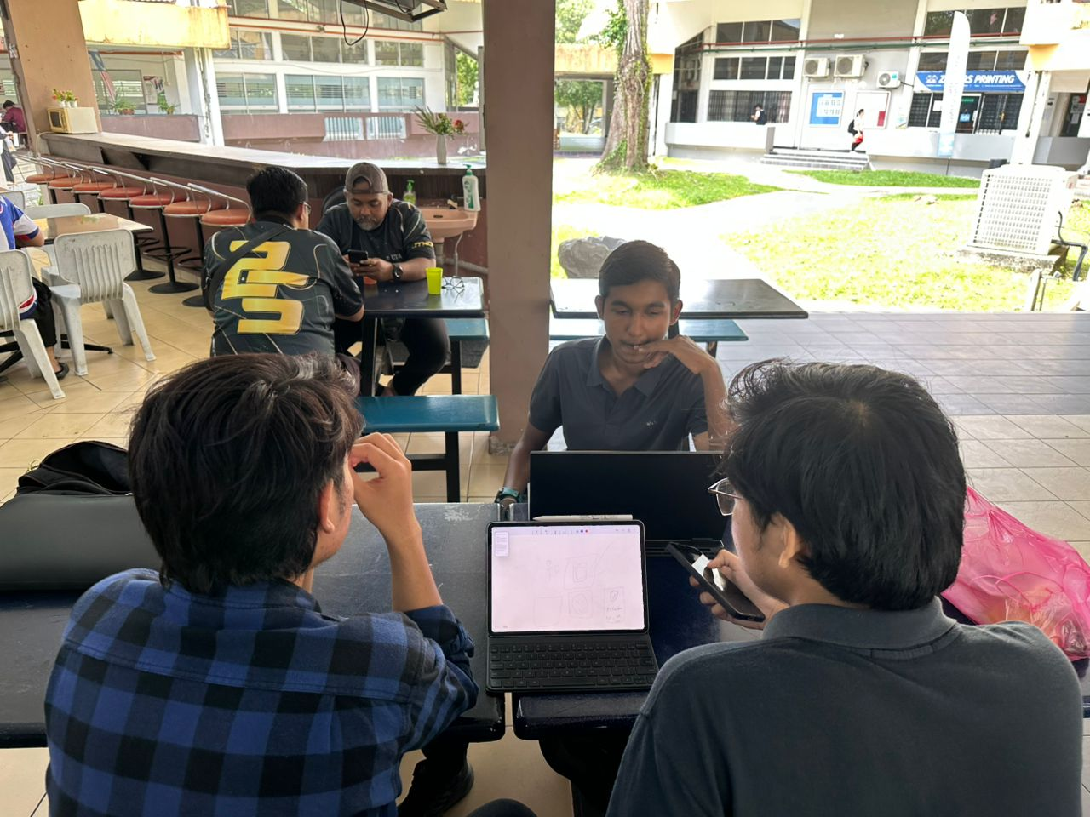

Picture 1: Physical discussion during empathy phase

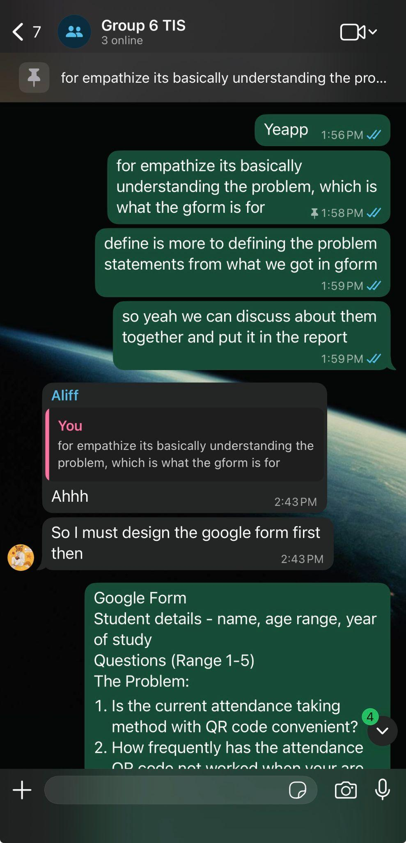

Picture 2: Online discussion during empathy phase

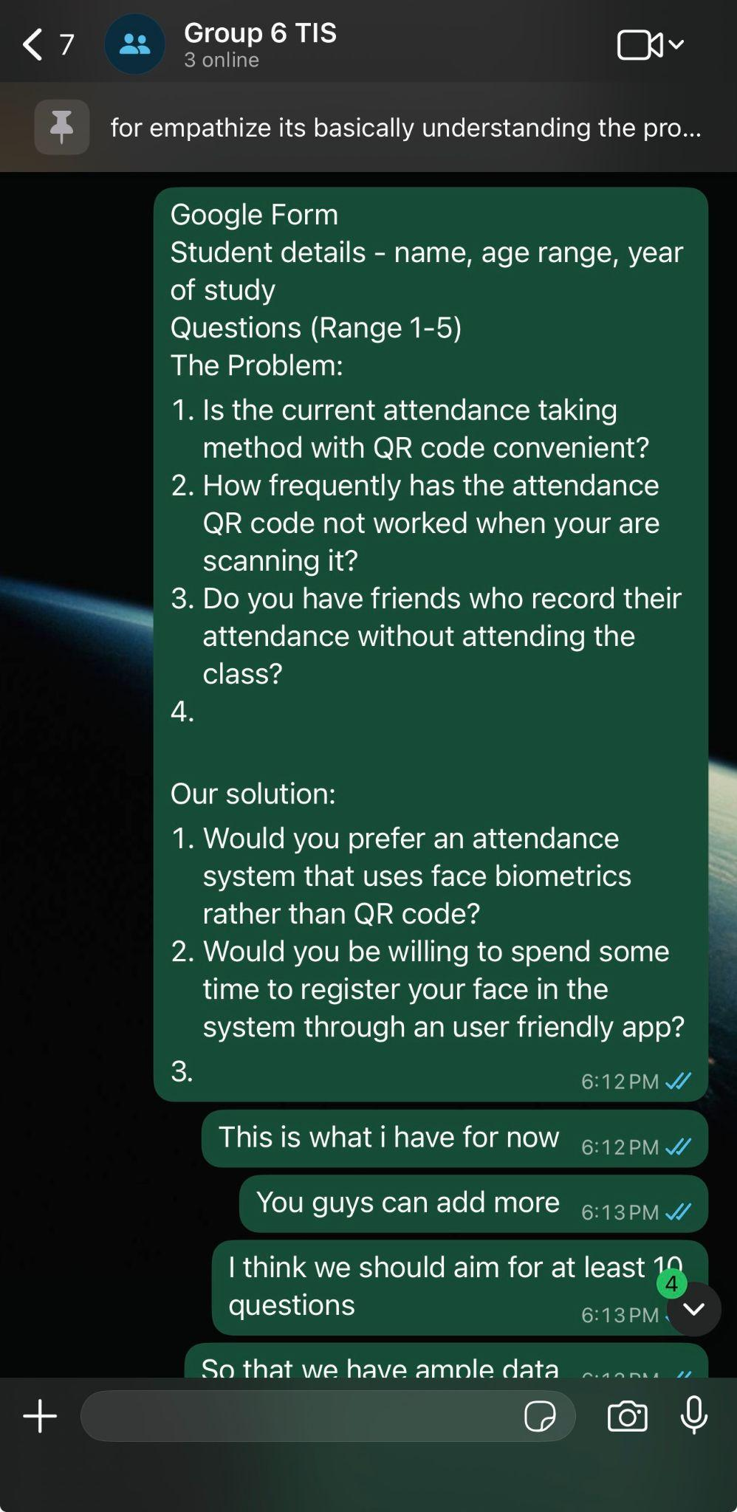

Picture 3: Online discussion about survey form

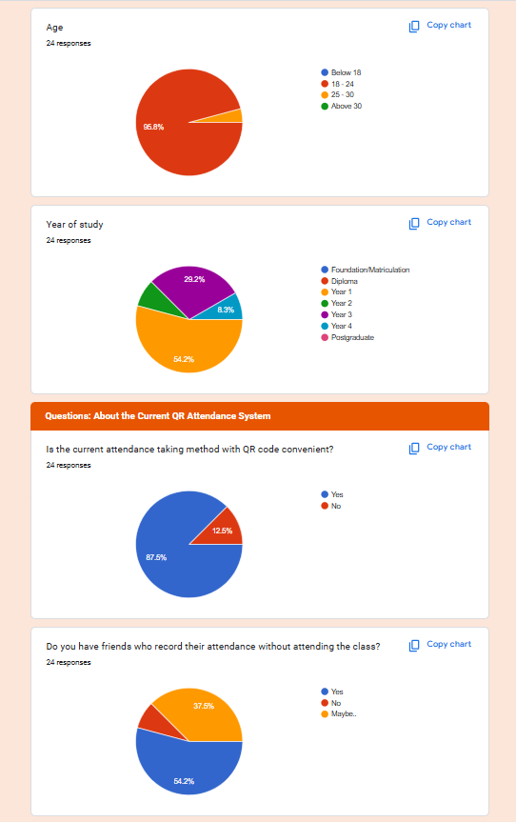

Picture 4: Responses from student survey form about attendance system

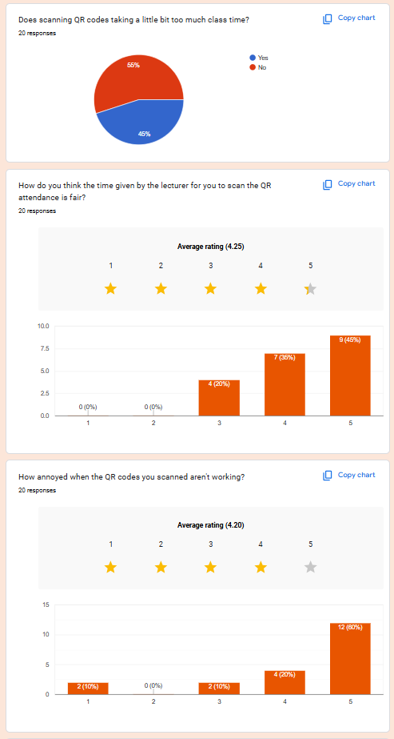

Picture 5: Responses from student survey form about attendance system

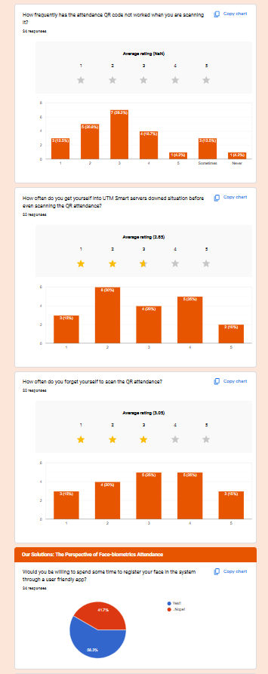

Picture 6: Responses from student survey form about attendance system

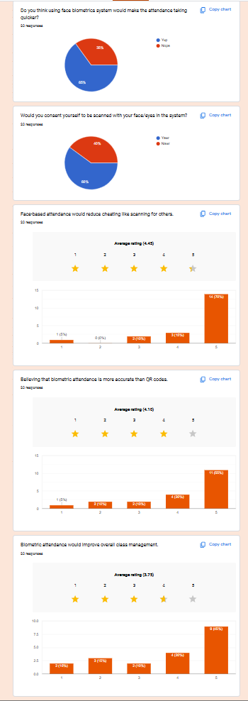

Picture 7: Responses from student survey form about attendance system

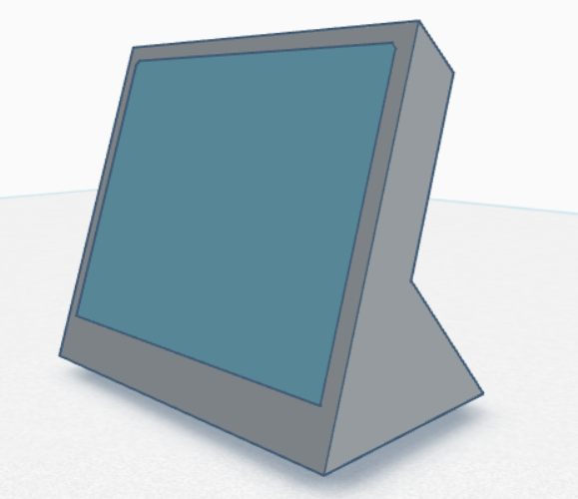

Picture 8: Mockup 3D design of biometric face scanner

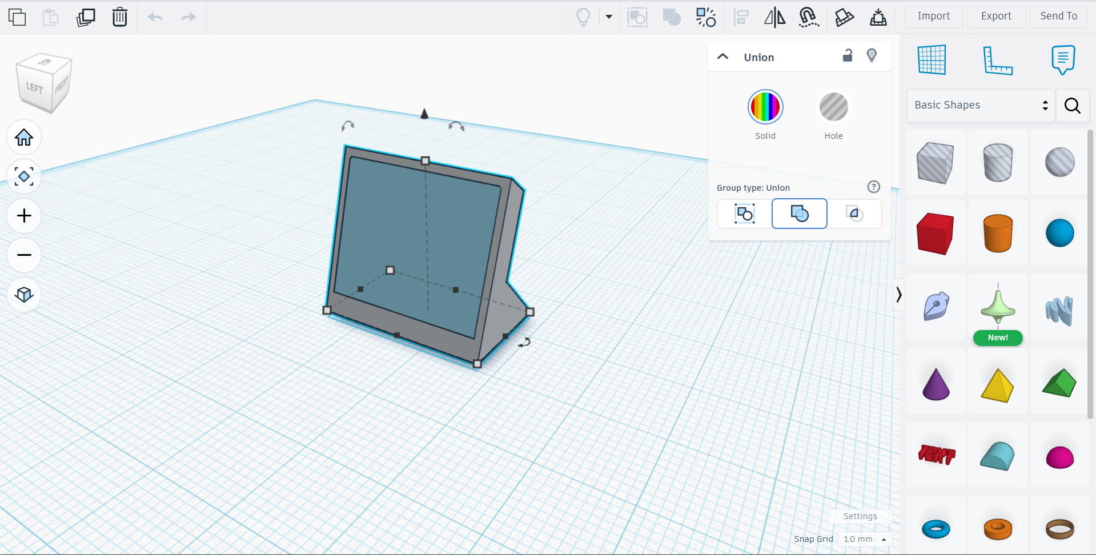

Picture 9: Designing the mockup model using Tinkercad

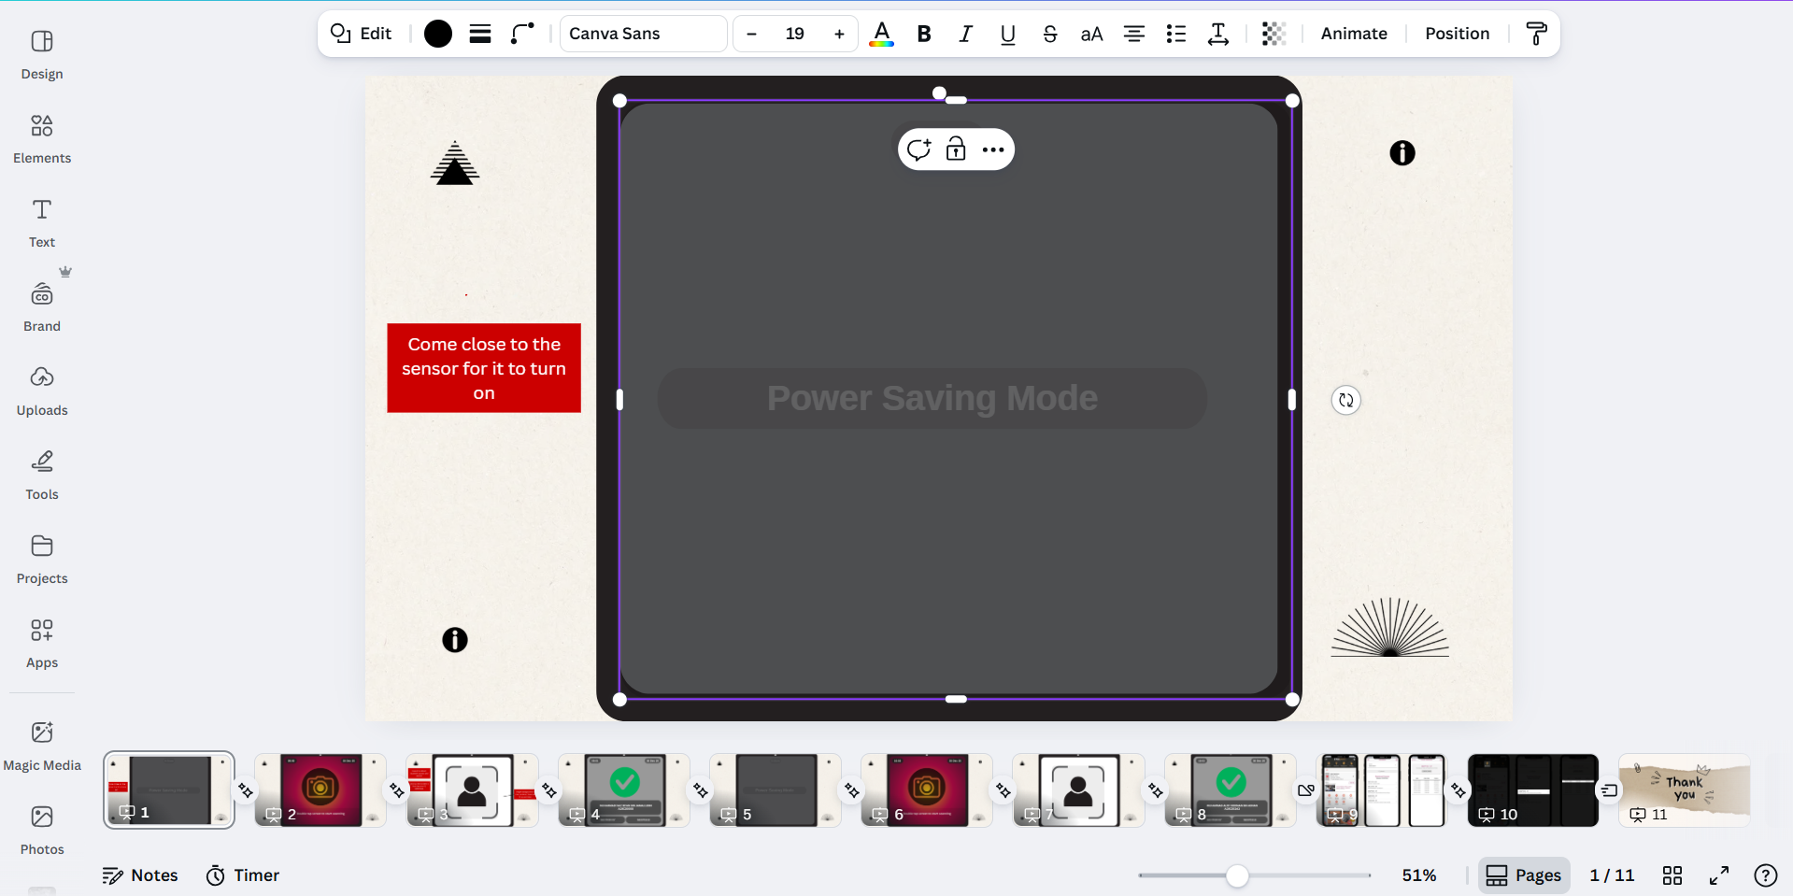

Picture 10: Designing the face scanner interface prototype using Canva

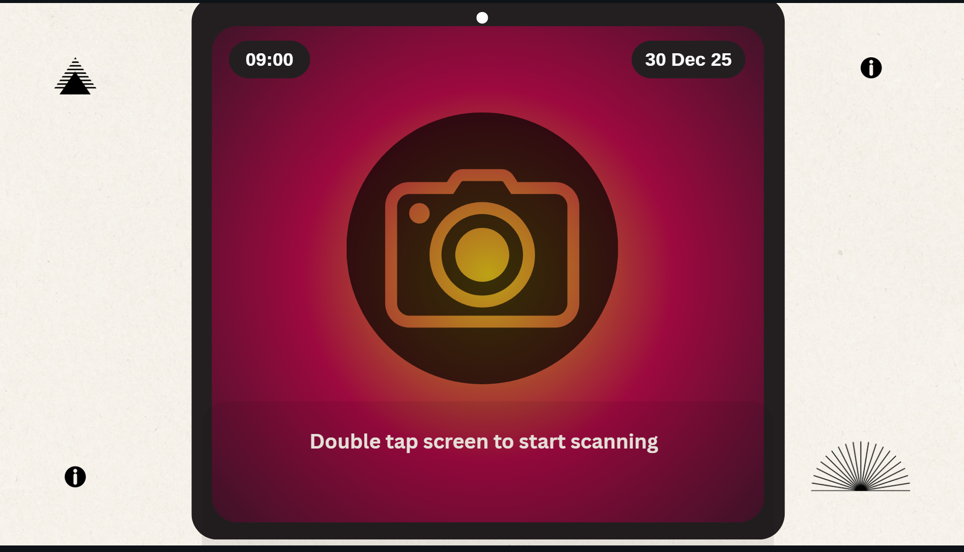

Picture 11: Face scanner interface prototype

**4.2 Record for Each Phase**

**4.2.1 Empathy**

The first composite character is Farah, a 20-year-old, 2nd-year Computer Science student at UTM. Farah constantly faces issues with the current QR-based attendance system in UTM and feels it is adding unnecessary stress to her education process. The second composite character is Dr. Faiz, a 45-year-old, Digital Logic Lecturer at UTM. Dr. Faiz teaches back-to-back to classes and frequently has to spend some time troubleshooting QR code issues.

**List of questions and answers for Farah:**

|  |  |
| --- | --- |
| **Question** | **Answer** |
| Is the current attendance taking method with QR code convenient? | Yes but it can be better. |
| Do you have friends who record their attendance without attending the class? | I do have a number of friends who ask my help to send them the QR code while they are not in class. |
| Does scanning QR codes take too much of the lecture time? | Yes, especially when you don’t have the best camera quality on your phone. |
| How frequently has the attendance QR code not worked when you are scanning it? | I would say about 40 percent of the time the QR code would not work due to environmental factors like lighting or internal error. |
| How often do you forget to scan the QR attendance? | Quite often, especially when the lecturer did not give us enough time to scan the QR code at the beginning of the class. |
| Would you be willing to spend some time to register your face in the system through UTMSmart? | Yes, as long as it takes a short amount of time. |
| Do you think using a face biometrics system would make the attendance quicker? | I believe it will as it would not require me to use my device or UTMSmart app |

Table 1: Questions and answers for composite character Farah

**Observations done during Dr. Faiz’s class:**

1. Has to spend 5 to 10 minutes troubleshooting the QR code, or MyUTM portal.
2. Sometimes forgets to display the QR code to students.
3. Shows the QR code for a short amount of time since he has to stick to the lesson plan.
4. Can get visibly frustrated when the attendance system is continuously not responding.
5. Has to take attendance manually when the attendance system is down.

**4.2.2 Define**

**Determining the big takeaways from empathy phase:**

|  |  |
| --- | --- |
| **Takeaway** | **Description** |
| Students’ time get wasted while using QR-based attendance system | Students have to spend extra time to scan the QR code. Factors such as lighting and phone camera quality can affect the success rate of scanning the displayed QR code. |
| Students can cheat with the current attendance system | Students who did not attend class can get the QR code from their friends. This causes the attendance to be inaccurate and does not represent actual reality. |
| Lecturers and students feel stressed when facing issues with attendance system | When UTMDigital servers and the UTMSmart app are experiencing downtime, lecturers cannot generate and display the attendance QR code. Consequently, students will not be able to record their attendance and cause frustration for both students and lecturers. |
| Lecturers struggle to adhere to lesson plan due to issues in current attendance system | Lecturers have to spend a part of their teaching time to troubleshoot issues with the attendance QR code and this will distract them from the teaching process itself. Lecturers would not be able to meet the lesson objective and cause delays in finishing the syllabus. |
| UTM students are interested in an alternative solution for the attendance system | When we suggested whether students would like a system that replaces the QR code based attendance system, the majority of students showed profound interest. They would like to use a system that is reliable, seamless and secure. |

Table 2: Main takeaways and their descriptions from the empathy phase

**4.2.3 Ideate**

**Brainstorming ideas for the solution:**

|  |  |  |
| --- | --- | --- |
| Idea | Advantages | Disadvantages |
| Use high-definition CCTV cameras to automatically track students' presence during lectures. | Completely invisible and hands-free for students and lecturers. | High installation costs for the CCTV system and privacy concerns regarding constant monitoring. |
| Use a self-designed biometric face scanner to record student attendance. | Secure, reliable, prevents cheating, works offline, and portable. | Requires self-designed biometric face scanner. |
| Utilise faculty WIFI logs to detect presence of students. | Zero new hardware required since it utilises already existing WIFI infrastructure. | Cannot exactly determine if students entered the class. |
| Voice recognition check-in before entering class. | Seamless and prevents cheating. | May not work properly with background noise and can struggle to detect students’ voices. |
| Use students’ matrix cards to register attendance with an NFC card scanner. | Fast, easy to use, and requires low upfront costs to implement. | Cannot prevent cheating as students can also scan a friend's matrix card. |

Table 3: Ideas for the solution and their respective advantages and disadvantages

**4.2.4 Prototype**

**Prototype Operational Workflow**

1. A self-designed biometric face scanner that is cost-efficient and portable will be used.
2. The scanner can be placed on a table inside or outside the class.
3. Students scan their faces in front of the scanner, guided by the user interface.
4. The scanner sends the data to UTMDigital servers and uses AI to analyse the data.
5. If servers are down or have no network connection, the scanner stores the data temporarily while servers or the network are recovered.
6. Students can then check their attendance status in the UTMSmart app.
7. Lecturers can monitor their students’ attendance in UTMSmart or MyUTM Portal.

**Prototype Development**

The prototype development for our solution is divided into two parts. The first part is developing the mockup model for the portable biometric face scanner while the second part is designing the user interface for the face scanner.

**Mockup Model of Biometric Face Scanner**

The main attributes the biometric face scanner needed was to be portable and cost-efficient. We designed the biometric face scanner to be in a small-form factor and made out of recycled plastic to reduce cost. The scanner would consist of a body, LCD touchscreen, camera, motion sensor, battery and charging port. The front part of the body would house the LCD touchscreen, camera and motion sensor. This front part is tilted to a 45 degree angle to have an optimal view of the students face as the product will be placed on a table. We utilised a free, web-based 3D design software called Tinkercad by Autodesk to create a mockup model of the face scanner. It was easy to use and was capable of designing simple 3D models.

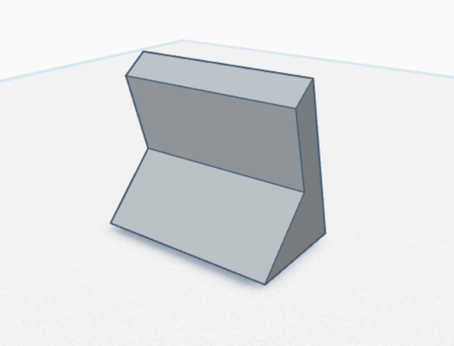

Picture 12: Back view of the biometric face scanner



Picture 13: Front view of the biometric face scanner

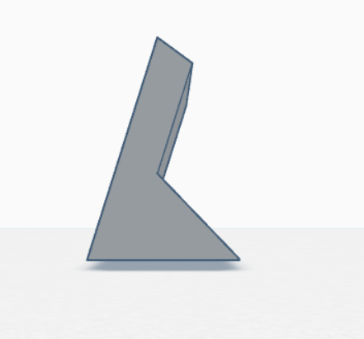

Picture 14: Side view of the biometric face scanner

**User Interface of Biometric Face Scanner**

We aimed to have a simple and minimalistic user interface that would guide students on how to use the face scanner and record their attendance. We created the prototype for the user interface using Canva by replicating the front view of the face scanner. We then designed the user interface on the LCD touchscreen area and showed how the user interface will guide students to record their attendance.

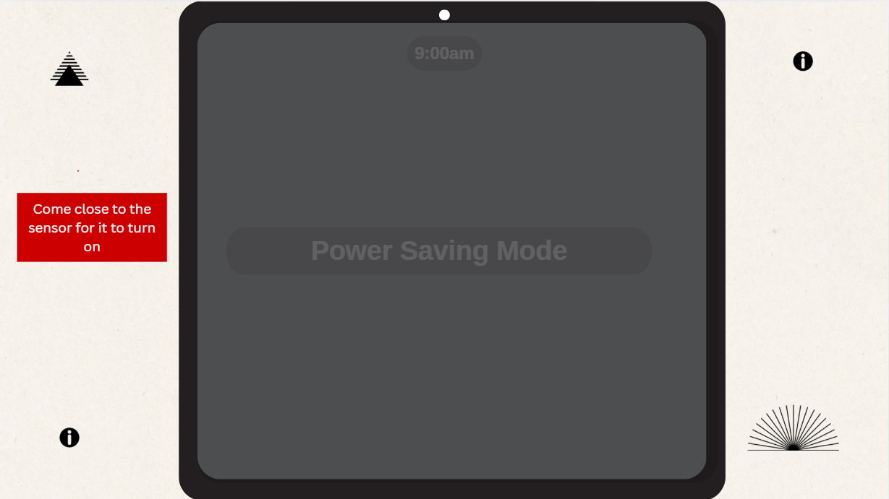

Picture 15: User interface in power saving mode where there is no activity detected

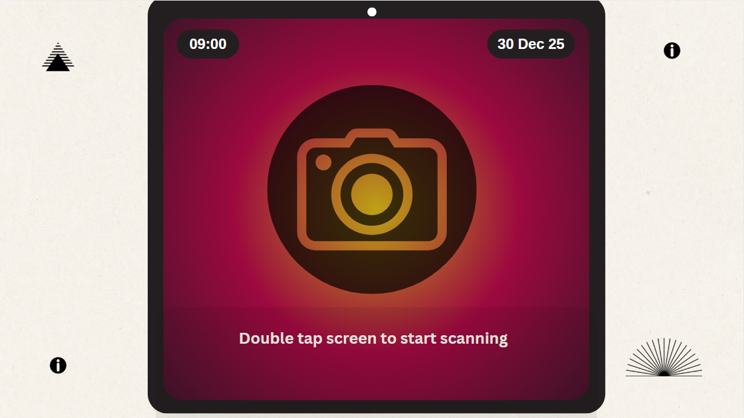

Picture 16: User interface when motion detected by sensor

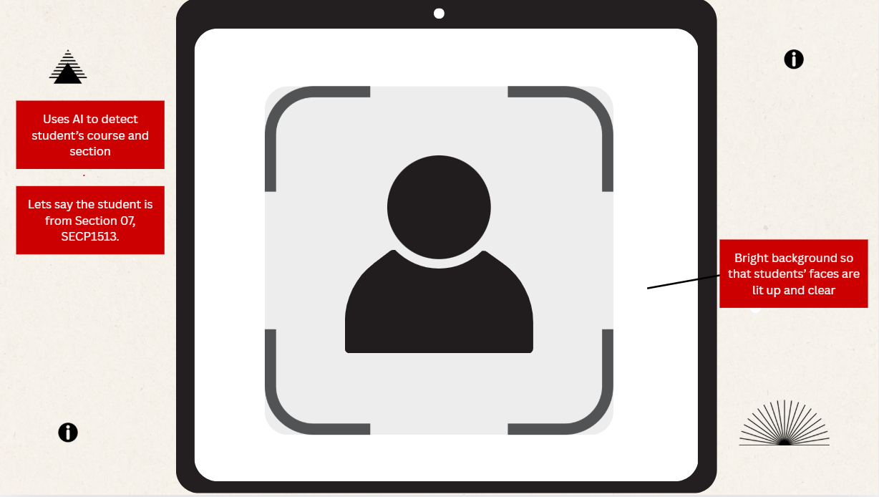

Picture 17: User interface when screen is double-tapped

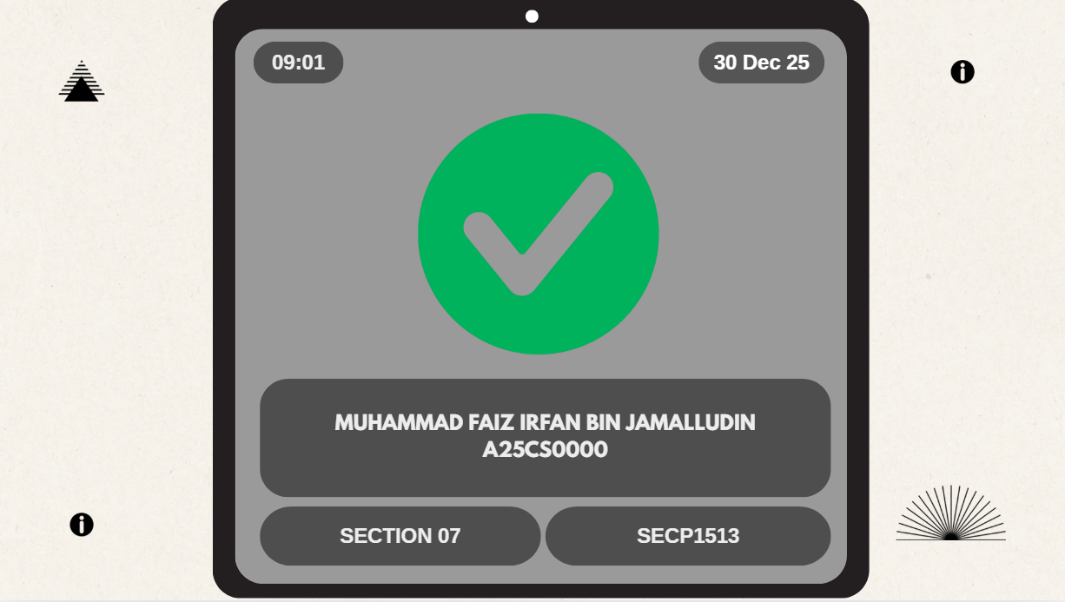

Picture 18: User interface when face is successfully scanned

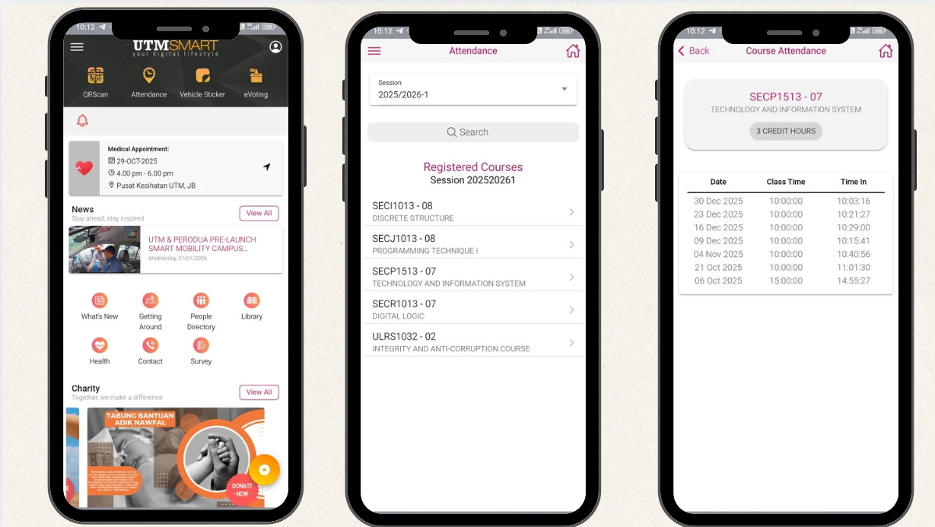

Picture 19: Attendance status will be updated in UTMSmart once student face is scanned

**4.2.5 Test**

**Prototype Feedback and Improvements**

|  |  |
| --- | --- |
| **Feedback** | **Improvements** |
| Students should still be able to check their attendance in UTMSmart to verify that the system recorded their attendance | Improvised the prototype plan so that the scanner would send data to UTMDigital servers and update the attendance in UTMSmart |
| The scanner cannot scan faces when its facing at a 90 degree angle | Improved the design so that the front part of the scanner is tilted at a 45 degree angle facing upwards |
| Keep the user interface simple | Removed extra unnecessary elements from the user interface |
| Can add LED light to ensure the student face is lit during dim lighting conditions | Added feature in user interface to display bright white screen when scanning student face |

Table 4: Prototype Feedback and Improvements

**5.0 REFLECTIONS**

**Dhivyesh Kumar A/L Sivakumar (A25CS0212)**

This design thinking project has been a wonderful journey and I gained a lot of new knowledge regarding the design thinking process and how to implement it effectively. Ultimately, my goal with this course is to know how computing is applied in today’s industry and how computing knowledge is crucial in developing new technologies and accelerating the growth of different sectors in the economy. The design thinking project that I have completed would help me pursue my own hobby projects and improve my project management skills that are critical for surviving the current job climate. Hence, to enhance my capabilities to serve the industry later, I would get myself involved in impactful projects that can allow me to contribute to our society and upgrade my interpersonal skills.

**Muhammad Aliff Norman bin Adnan (A25CS0262)**

Our design thinking project gave me some perspective on how to put yourself into customer reviews. My main role was providing questions to clarify user’s problems giving their opinions on our current system we have through Google form. We then received important feedback which helped our project design better. After that, we concluded that a biometric facial system is essential to be implemented instead. This really helps me improve on my data analyzing skills and my advertisement overview. In the future, I would finally find myself important to be a part of a company’s group project; team leadership as we can’t work alone all the time as human beings. Therefore, I can give my own responsibilities toward an industry that is looking for a game developer, web designer or graphic designer.

**Muhammad Zahin Faris Bin Lokman (A25CS0284)**

The design thinking project helped me understand how to solve problems by focusing on users and their needs. I learned how to collect feedback, discuss ideas with my teammates, and improve our solution step by step. This project also showed me that computing is not only about technical skills, but also about teamwork and communication. Working together as a group improved my confidence and responsibility in completing tasks. Overall, this experience prepared me better for future projects and helped me develop useful skills for my studies and future career.

**Muhammad Faiz Irfan bin Jamalludin (A25CS0268)**

This design thinking project helped me understand how to solve problems by focusing on users and their needs. I learned how to collect feedback, work with my teammates, and improve our ideas step by step. The project showed me that computing is not only about technical skills, but also about teamwork and communication. Working in a group helped me become more confident and responsible when completing tasks. Overall, this experience prepared me better for future projects and helped me develop useful skills for my studies and future career.

**Ahmad Muaz bin Muhamad Thalhah (A25CS0177)**

This design thinking project gave me first hand experience on how to manage a project. Throughout the process, I learned a lot about the importance of teamwork and communication skills especially when everyone has their own personal responsibilities. The biggest takeaway I got from this project is that it's not about perfection, but rather execution. Being understanding and encouraging is very important especially when working with others. Overall, this experience prepares me for future projects and group based activities.

**6.0 TASK DELEGATION**

|  |  |
| --- | --- |
| **Name** | **Tasks** |
| Dhivyesh Kumar A/L Sivakumar | Design Thinking Description and Evidence |
| Ahmad Muaz Bin Muhamad Thalhah | Prototype Design |
| Muhammad Aliff Norman Bin Adnan | Introduction, Survey Form |
| Muhammad Faiz Irfan Bin Jamalludin | Prototype Design |
| Muhammad Zahin Faris Bin Lokman | Interview |

**7.0 REFERENCES**

Dam, R. F. (2025, July 18). *The 5 Stages in the Design Thinking Process*. IxDF - Interaction Design Foundation. <https://www.interaction-design.org/literature/article/5-stages-in-the-design-thinking-process>

Hasso Plattner Institute of Design at Stanford. (2025). *An introduction to design thinking: Process guide*. Stanford University.<https://web.stanford.edu/~mshanks/MichaelShanks/files/509554.pdf>

Verma, N. (2025). *Don’t solve dumb problems | Problem statement examples*. Business Management Blog.<https://businessmanagementblog.com/problem-statement-examples/>

Faggella, D. (2016, October 11). *What is artificial intelligence? An informed definition*. Emerj Artificial Intelligence Research.<https://emerj.com/what-is-artificial-intelligence-an-informed-definition/>

U.S. Department of Homeland Security. (2025, August 28). *Biometrics*. <https://www.dhs.gov/biometrics>